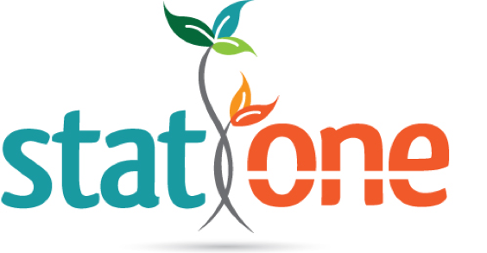

© 2018 All Rights Reserved | Stat One LLC | Contact (919) 244-7707 | statonellc.com |

* Stat One has extensive cardiovascular experience involving submissions with medical devices, pharmaceuticals and biologics. We have has also supported thorough QT (TQT) studies.

***CARDIOVASCULAR EXPERIENCE***

© 2018 All Rights Reserved | Stat One LLC | Contact (919) 244-7707 | statonellc.com |

**Pharmaceuticals/Biologics:**

* Heart failure therapies
* Stress agents (adenosine type subjects)
* Contrast agents
* Clot preventing treatments.

**Devices:**

* Stents
* Ablation treatments of atrial fibrillation.
* Grafts for the treatment of peripheral vascular disease.
* Contrast agents and imaging studies.
* Clot removing catheter devices.
* Diagnostic devices measuring blood pressure through various measures.

***DEVICES & PHARMACETUICALS***